**Research Studies in the Field of Telecommunications - 2011**

**Inauguration of the Research Studies Program & Initial Proposal Presentations.**

28th September 2011

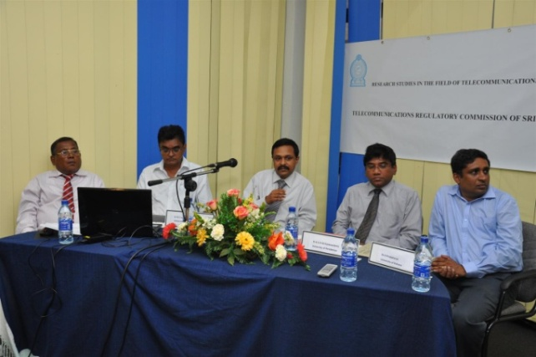 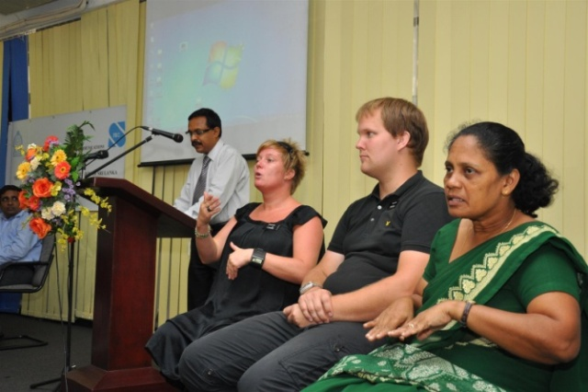

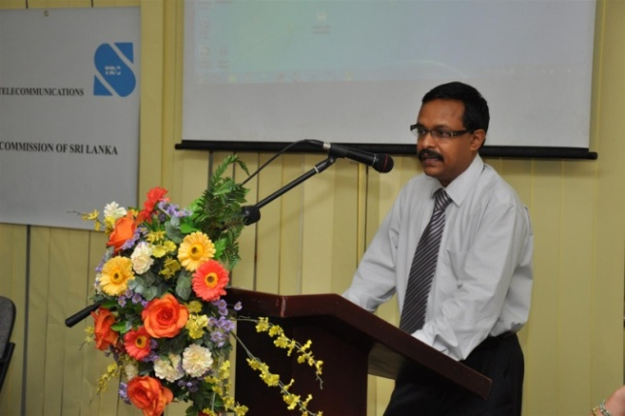 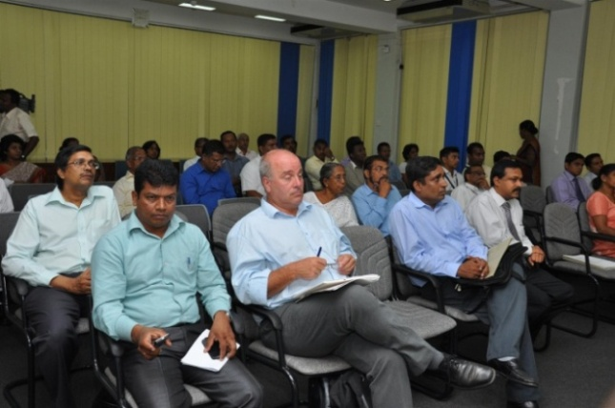

**The following Research Proposals were selected for Implementation with the assistance of the Universities.**

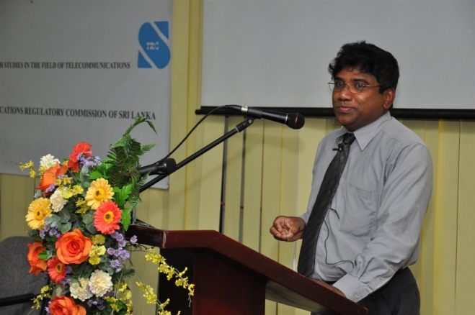

**[Development of a low-cost Measurement Setup for Microwave Measurements up to 8 GHZ](http://www.trc.gov.lk/images/docs/1rnd.ppt)**

**Dr. A. U. A. W. Gunawardena, Senior Lecturer, Department of Electrical and Electronic Engineering, Faculty of Engineering, University of Peradeniya**

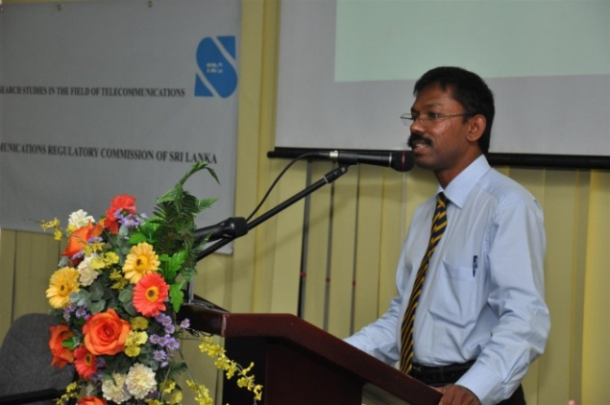

**[Scalable Methods for P2P Traffic Surveillance](http://www.trc.gov.lk/images/docs/2rnd.ppt)**

**Dr. Chandana Gamage, Head of the Department, Department of Computer Science and Engineering, Faculty of Engineering, University of Moratuwa**

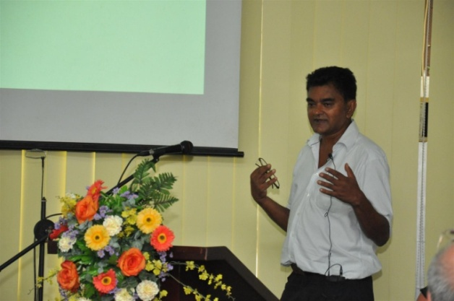

**[Sign Language Interpreter (SLI)](http://www.trc.gov.lk/images/docs/3rnd.ppt)**

**Dr. N. D. Jayasundere, Senior Lecturer, Department of Electrical and Information Engineering,**

**Faculty of Engineering, University of Ruhuna**

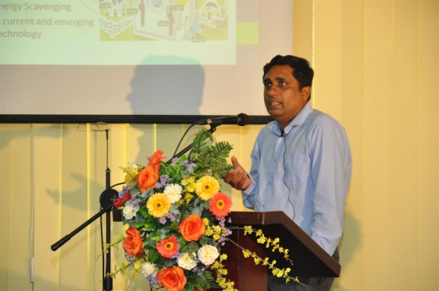

**[Design of a Micro Scale RF Harvesting Unit](http://www.trc.gov.lk/images/docs/4rnd.ppt)**

**Dr. K. Pirapaharan, Senior Lecturer, Department of Electrical and Information Engineering,**

**Faculty of Engineering, University of Ruhuna**