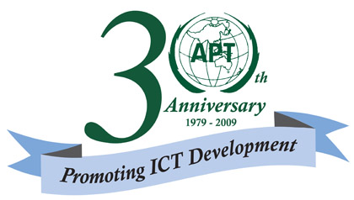 |  |  |  |  | 
 | The Eleventh South Asian Telecommunication Regulators Council Meeting (SATRC-11)
24 – 26 November 2009
Colombo, Sri Lanka

provisional agenda

- Opening
- Adoption of Agenda
- Chairmanship of SATRC

Industry-Regulator Dialogue
- Presentation of Reports from the Working Groups
- Review of the SATRC Action Plan (Phase-II)
- Discussion on new topics for consideration in the Action Plan
- Adoption of SATRC Action Plan (Phase III)
- Date and venue for the next SATRC Meeting
- Closing

